NAME : _____________________________STORY______________________________
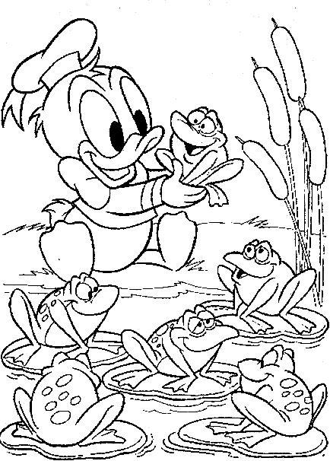

COLOR THE FROGS IN GREEN

